1. We first made a function to seed our DB with sample data

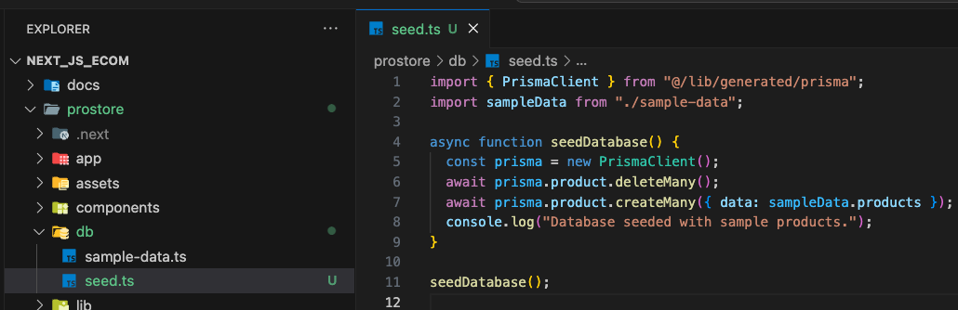

1. Then run it using NPX.

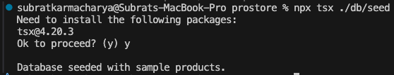

1. And we have the dummy data seeded

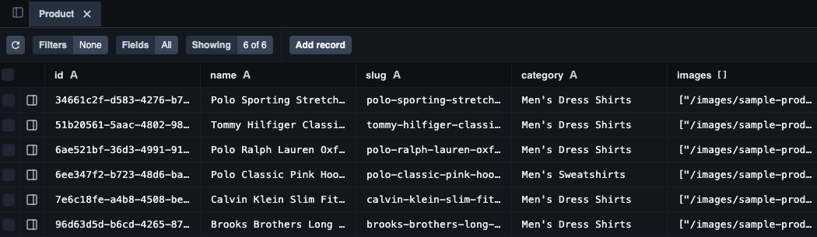

1. As this site is a monolith application. Like we will not have exposed API for the mobile apps or any other platforms. So, we will be using server actions of next js.

Basically, we won’t be making the old API routes. We will still be using node js under the hood anyway. But we will simplify this API making process using server actions.

* First, we make a new actions folder and file

* Then, we will map the products from the database we just seeded as an export function

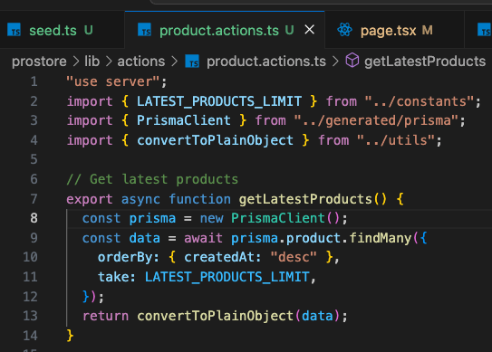

* Then we will use it instead of the hardcoded data.

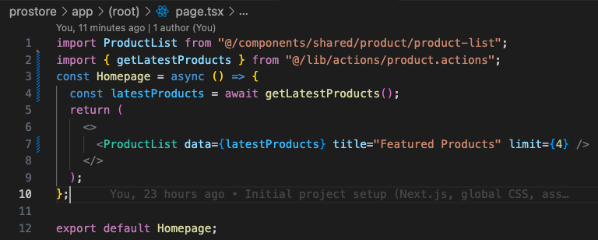

* Also, we got some error because we were mapping the Prisma object. So, we made a function to convert the Prisma object to normal JSON.

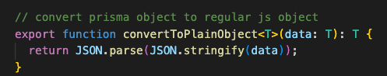

Here the T Is the type and final T implies that the return is of same type.

* We already see this in action in above

